MINIMUM WAGE INCREASE

Sarvenaz Ahmadifar
ECON 2301-702
04/05/2020

A minimum wage is the lowest legal wage that a company can pay its employees. Minimum wage increase has been a headache to the government of the United State of America, in which the current wage is $7.25 per hour. Consequently, the people who could support this are workers advocates. The minimum wage increase is so crucial in that first, workers that have the potential to cover their cost of living have better morale, thus they can only be productive only if they have a decent living standard. Secondly is that through providing incentives work which makes a universal basic income this reduces income inequality. Thirdly, the minimum wage increase gives more money to the works to spend, hence promoting economic growth which in turn increases the business demand and revenue. Lastly, much time and more money can lead to investment this increases their productivity and attractiveness of their country's labor of pool. With this Initiative, there are some of the implications that it must have and these are: First it is not an unfunded mandate that falls on the business shoulder. Secondly, the minimum wage increases business labor costs. This may lead to the employment of a few workers this leading to unemployment. Furthermore, minimum wage laws may increase job outsourcing. And lastly, it may raise the cost of living in some areas, these landlords could raise rents which creates inflation.
The authors try to argue on deferent ways to pocket this amount on their employees directly. The study that was conducted by John P. Formby, John A. Bishop and Hoseong reveal that these increase in wages are not well-targeted at poor and low-income population. And besides, they came p with the other two alternatives; Federal insurance Contribution act (FICA) and Earned Income Tax Credit, which could be less costly and effective. And thus I would support FICA and EITC sense that they are less costly.
The minimum wage increase is essential to the employees in that it gives the worker more money to spend which lately will result in and increases in business demand and revenue, hence supporting the economic growth. Furthermore, it provides workers with morale hence increasing their productivity. In addition to that minimum wage increase improves the living standard of employees with an ability to cover their cost of living. And lastly is that an increase in income may lead to investment this improve and attracts the country's labor of pool. I may not also support this argument in that it leads to inflation through an increase in commodities and housing altogether. Another point is that it may lead to unemployment and the loss of jobs f the company collapse. On top of it, the minimum wage penalizes companies that are labor-intensive. By default, this rewards those that are in capital-intensive industries. Over time, this can shift the very fabric of the country's economic base. Some research shows that a minimum wage can increase the number of jobs in an economy. Businesses find other ways to offset higher labor costs. They raise prices or reduce the number of hours worked. Thus worker morale, productivity, and consumer spending all increase at once. In setting a minimum wage, the government has to find the sweet spot between protecting workers and giving businesses the flexibility they need to remain competitive.
The authors conducted studies and have come up with empirical evidence that shows that there is no relationship between higher minimum wage and a reduction in poverty. Economists have identified three confounding factors: First is that many people living in poverty do no work and this cannot benefit from the high wage. Secondly, it is also found that the large populations of low-income earners are not poor and not living n the poor family. And finally raising the minimum wage may have unintended consequences. Joseph Sabia and Robert Neilsen have gone for the extra mile to survey data from Census Bureau's Survey of Income and Participation and then came p with the following measures: Financial insecurity, that is whether someone is has been n able to pay his or her utility. Others are; food security, that is if one is able to buy food; Housing security and health security. Across all measures, the authors find that there is no statistically crucial evidence that higher minimum wage has helped to reduce financial, food health and hosing security. This is true across all employees in general and for smaller sub-sets of the less-educated and less-experienced. As one explanation of their findings, the authors show that over half (54.7 percent) of poor, less-educated individuals between ages 16 and 64 do not work. A similar percentage (53.6 percent), of individuals who report missing a rent or a mortgage payment, does not work. Thus, many of the people policymakers are trying to help won't benefit because they're not working.
Even among those who are working the minimum wage appear to be poorly targeted. Bout eighty-seven percent of wage earners who benefitted from the forty percent increase in a state supplement reduces poverty rates by one percent. Furthermore, it also provides an incentive to seek employment since the credit can only be claimed on income. It is vividly evident that increasing the minimum wage is a poor way to reduce hardship for targeted employees. Thus it would be wiser to consider other alternative ways such as an expansion of the EITC. We find that each and every author uses his or her evidence to support his or her argument and indeed it works. John P. Formy and John A. Bishop are qualified to be authors since they have come with a new idea and alternative ways to handle the cases of the minimum wage increase. Coming to their biasness, they have shown s that FMWA does not have a direct link with workers' pockets and has worked hard to come up with an alternative method that is cost-effective. Census Bureau data found that they would be poorly targeted to the low-income families they’re intended to help. This is consistent with a wide body of economic research finding that minimum wages are a poor way to reduce poverty, and also reduce employment opportunities among the least-skilled.
On debates over whether to raise the minimum wage, proponents often try to boost their credibility by referencing a group of 15 prominent economists who support a minimum wage increase, as well as approximately 650 additional economists in agreement. This list, first compiled and released by the Economic Policy Institute (a labor-backed organization), is still cited frequently to counter the claims of labor economists who argue that raising the minimum wage could cause job loss. The list was even inserted into the Congressional Record by Congressman George Miller (D-CA) during the last debate over raising the United States federal minimum wage. But a closer examination of the list by the Employment Policies Institute (EPI) reveals that nearly 60 percent of the economists studied don’t specialize in labor economics—and some aren’t even economists at all.
At best, this list from the Economic Policy Institute represents the opinion of roughly 20 percent of the country’s labor economists—a fitting reality, given that an earlier survey of the country’s labor economists from the University of New Hampshire found 73 percent in agreement that a mandated wage increase would decrease entry-level employment. It also found that the average family income of a beneficiary of a wage hike to $9.80 is $50662—well above the $15,080 year-round income figure cited by proponents of wage hikes. Secondly, well over half—nearly 57 percent—of the beneficiaries of a $9.80 minimum wage are either living at home with family or have a spouse who also works. Less than 10 percent are single parents with children. Thirdly Beneficiaries of a $9.80 minimum wage tend to be young—41.5 percent of those directly affected are age 25 or under. The two industries with the greatest number of impacted employees are Retail Trade (e.g. grocery stores or gas stations), and Arts, Entertainment, Accommodations, and Food Services(e.g. restaurants or hotels.)
Earlier studies have projected at least 467,500 lost jobs following a wage hike of this magnitude. Accounting for the smaller labor force post-Recession, job losses in the range of 256,200 to 768,600 are projected based on results found in earlier economic literature. Perhaps surprisingly, not very many people earn minimum wage, and they make up a smaller share of the workforce than they used to. According to the bureau labor of statistic, last year 1.532 million hourly workers earned the federal minimum of $7.25 an hour; nearly 1.8 million more earned less than that because they fell under one of several exemptions (tipped employees, full-time students, certain disabled workers, and others), for a total of 3.3 million hourly workers at or below the federal minimum. That group represents 4.3% of the nation’s 75.9 million hourly-paid workers and 2.6% of all wage and salary workers. In 1979, when the BLS began regularly studying minimum-wage workers, they represented 13.4% of hourly workers and 7.9% of all wage and salary workers. Furthermore, economists continue to debate the extent to which minimum-wage laws reduce poverty, income inequality and/or overall employment. What’s clear, though, is that after a three-step increase in 2007-09, today’s minimum wage buys more than it did recently, but its real purchasing power is about where it was in the early 1980s— and below its late-1960s peak. Even though the federal minimum wage has remained at $7.2 an hour since 2009, they have set $15 an hour as the new standard for all workers.
The idea of raising the minimum wage is vastly poplar and a pew research Center, in the previous August fond a clear partisan and racial difference in support. The research states that, overall, fifty-two Percent of people favored federal minimum wage increase which was $15 an hour. But the ideas were favored by just twenty-one percent of Trump supporter And while large majorities of blacks and Hispanics supported a $15 federal minimum wage, 54% of whites opposed it.

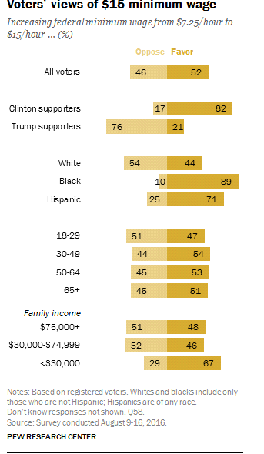
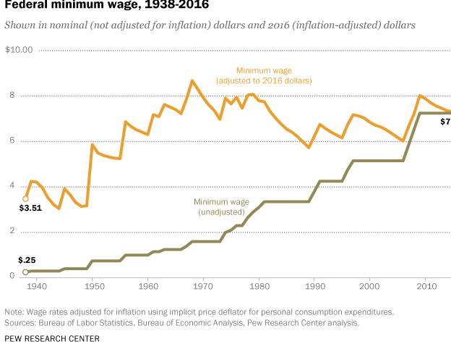
Work Cited
Kim, Taeil, and Lowell J. Taylor. "The employment effect in retail trade of California's 1988 minimum wage increase." Journal of Business & Economic Statistics 13, no. 2 (1995): 175-182.
Rebitzer, James B., and Lowell J. Taylor. "The consequences of minimum wage laws some new theoretical ideas." Journal of Public Economics 56, no. 2 (1995): 245-255.
Zavodny, Madeline. "The effect of the minimum wage on employment and hours." Labour Economics 7, no. 6 (2000): 729-750.

